[www.aksm.gr](http://www.aksm.gr)

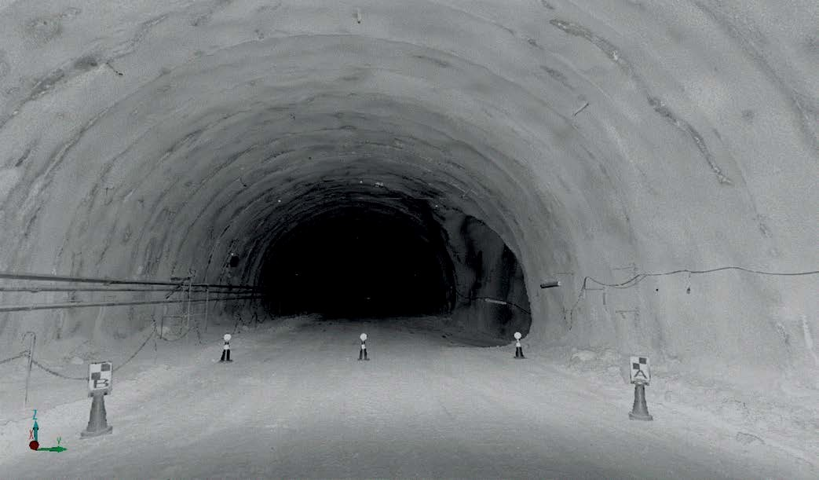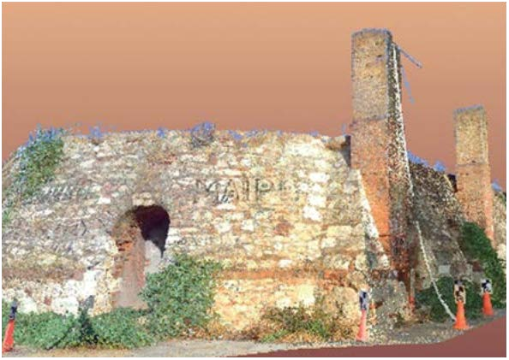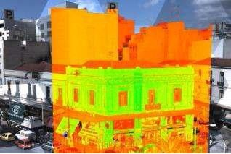

LASER SCANNING & BIM

Surveying Precision

BENEFITS

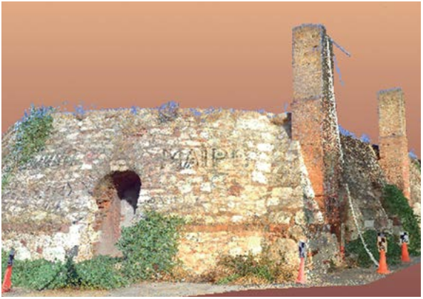• Improved – communication, collaboration

& transparency

• Lower – overall costs on build

• Reliable – quality checked data (model against scan)

• Faster – decision making, implementation of project alterations

• Less – time on site, missed data, rework, construction clashes

• Fewer – errors & costly mistakes, plan virtually

• Phased – scan & model parts of the

project when & if required

• Better – sustainability, using BIM throughout the building’s life.

• ‘What if’ – plans & sequences can be optimized virtually

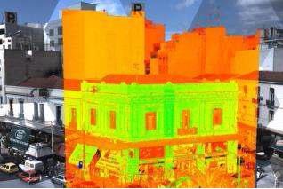

DELIVERABLES

• 3D laser scan point cloud

• Leica TruView dataset – accessed via web browser

• 3D intelligent BIM model

• Rendered visualizations & flythroughs

• Topographical survey of surrounding area

• 2D floor plans, elevations & sections (from

BIM model)

• 3D PDFs – accessed via Adobe’s free

Reader software

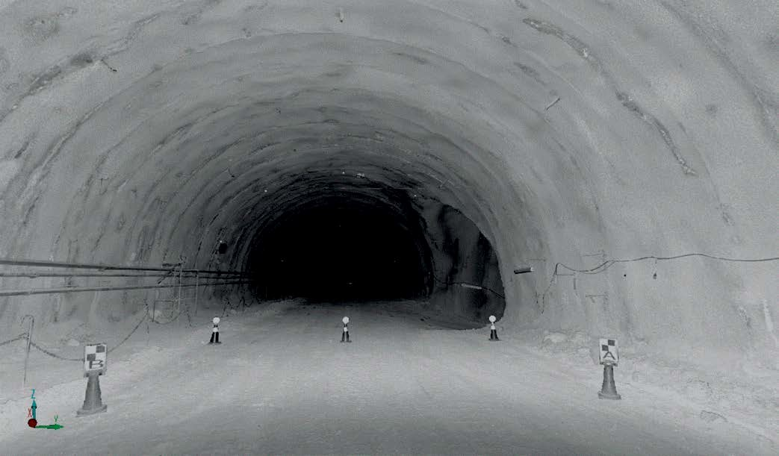

9